Designing Systems
  - Key Revision Facts: GCSE Technology

All electronic circuits can be shown as a Block Diagram, having an Input, Control, and an Output. Most electronic components fall into one of these categories.

Inputs
Below are a few examples of input components.
Thermistors sense the temperature change. The Thermistor resistance changes with temperature. | 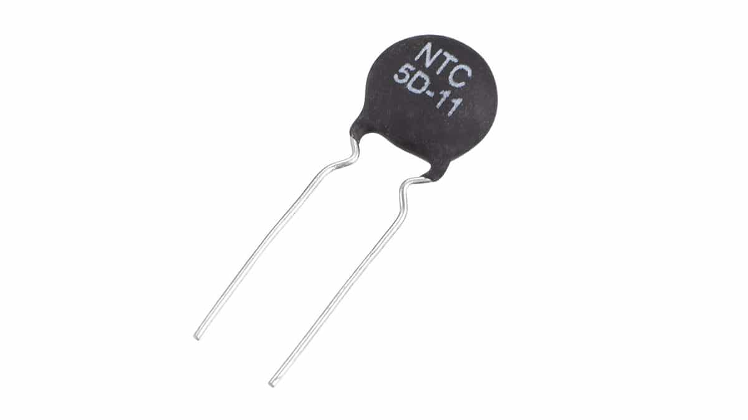 | 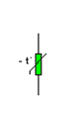
Switches come in many different styles,  with varying numbers of connections.  they are used to “make” or “break.” connections | 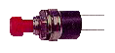 | 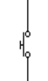
The Light Dependent resistor (LDR)  are used to sense changes in light and  the resistance changes with varying light levels. | 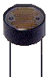 | 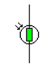

Control
Below are a few examples of control components.
555 Timers produces accurate delays or oscillations | 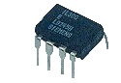 | 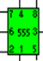
Transistors control the flow of the current. | 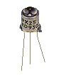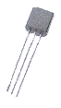 | 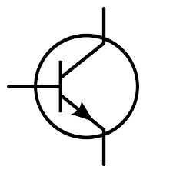
Micro-Controllers execute programable logic | 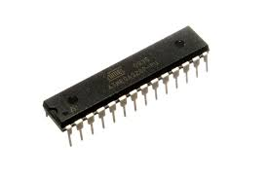 | 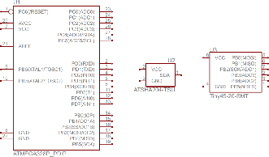

Outputs
Below are a few examples of output components.
Light Bulbs produce visible light | 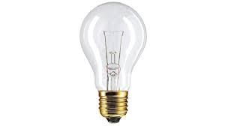 | 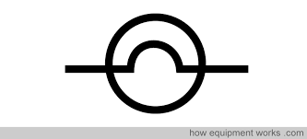
Motors produce rotational motion | 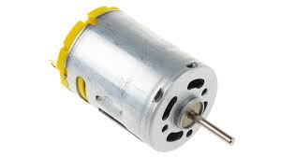 | 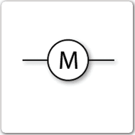
Buzzers produce sound | 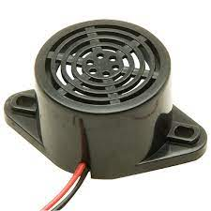 | 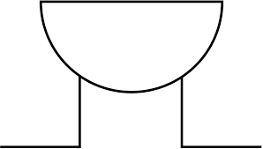

Download
More Key Fact Revision sheets can be downloaded from
www.andrew-seaford.co.uk/revision

Version information
Date | Arthur | Comment
17-Jan-2021 | Andrew Seaford | Initial release.

